CHAPTER 3: REQUIREMENTS, ANALYSIS, AND DESIGN

3.1 Overview
The Baze Smart Voucher system is a multifaceted digital voucher and payment application for Baze University to eliminate paper transactions between students and staff and the various restaurants on campus. The process involves an application with a back end QR code payment system. Many of the real life problems affecting campus restaurant operations are mitigated with the system, including:
- Cash payment and security concerns
- Extended payment stations wait times
- Difficulties in tracking payments and maintaining balances
- Limited payment options for students
- Manual ordering and inventory tracking operations.
Thus, this system is a one-stop-shop that consists of digital wallets with set balances, a payment system predicated on QR code scanning, a subscription application for each restaurant meal plan, a restaurant application for menu, orders, and staff creations and tracking, transaction submission, and report generation.

3.2 Proposed Model
The Baze Smart Voucher is based on a three-tier architecture model.
- Presentation Layer(Frontend): A Next.js 14 React web application for customer, restaurant, and admin interfaces
- Application Layer(Backend): Next.js API routes implementing business logic for processing, authentication, authorization, and manipulation
- Data Layer: MySQL relational database to store and serve all necessary system-related information (user database, restaurant menus, transactions, orders and subscriptions).
The system implements a role-based access controlled with the following three primary actors:
- Customers (Users): students and staff who purchase their meals
- Restaurants: food vendors who will be providing their services
- Administrators: those managing the system.
The proposed model emphasizes the following characteristics of the systems:
- Security: JWT authentication with http-only cookies
- Scalability: Modular design to add other elements in the future
- Usability: Easy-to-navigate interfaces for mobile and desktop alike
- Stability: Transaction reliability through database-level transactions
- Versatility: Payment through cash, digital wallet, or bank transfer.

3.3 Methodology
The development methodology most appropriate for this system is Agile Software Development, specifically using the Scrum framework. This is because Scrum is an iterative process that includes working software delivery along the way, allowing for time to pivot and adjust for changing development requirements.
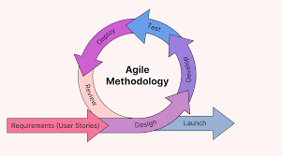

Figure 3.1: Illustration of Agile Methodology (Source: https://katharostechie.in/ )

Table 3.1: Agile Development Phases
Sprint | Focus | Deliverables
Sprint 1 | Setup and Authentication | Project setup, authentication creation/login/register
Sprint 2 | User Dashboard and Restaurant Creation | Customer dashboard, dashboard menu creation for restaurant, admin approval of restaurants
Sprint 3 | Menu and QR Code | Dashboard menu creation for restaurant, QR code for restaurant, and QR code menus
Sprint 4 | Order Creation and Payment Processing | Create an order from a menu, balance control management and transaction records
Sprint 5 | Subscription Creation | Subscription plans creation, subscription payment confirmation and balance crediting
Sprint 6 | Staff Management and Permission | Staff creation with specific permission who can create orders
Sprint 7 | Payment Enhancement Options | Payment in cash/transfer option with allowed receipt of payment option marked received
Sprint 8 | Testing, bugs fix and Implementation of Documentation | System testing, bug resolution, documentation completion

Table 3.2: Agile Risk Management
Risk Type | Risk | Mitigation (Agile Strategy)
Technical | Overloaded database | Performance testing ahead of time, database indexing, queries optimization
Technical | Reliability on QR code scan | Different qr code libraries, qr code fallback options are there
Technical | Authentication vulnerabilities | Security review each sprint, JWT best practices, security assessments every few sprints.
Requirements | Changing user requirements | Every week sessions and backlog grooming and sprint review when feedback is raised.
Requirements | Payment flow requirements are not clear. | User story mapping, prototype demonstrations, iterative feedback
Resource | Development resources are limited | Prioritized backlog, MVP focus, time-boxed sprints
Resource | Integration is complicated. | Integration testing was done first, created api-first, established continuous integration from the start to create credibility early on.
Quality | Limited test coverage. | Test driven development, automation for testing when needed, code reviews.
Quality | User may not like UI/usability. | Usability testing and user feedback sessions for iteration based on the sessions regarding the UI.

3.3.1 Method 1: Interviews
Interviews were conducted to ascertain systems requirements and involved university administrators to discuss integration and security, restaurant owners to discuss their way of working and payment methods, students and staff to assess user experience needs and concerns. These interviews revealed a need for various payment methods, a plan for subscriptions as an option for meal plan requests, a necessity to display stock in real-time and history of transactions with safety precautions for digital aspects of financial undertaking. Ultimately, through these interviews, the variety of roles necessary for proper access were confirmed, required payment flow was established, the need for functionality was corroborated and constraints of the system were unintentionally found (although not dismissed, should help in development anyway).

3.3.2 Method 2: System Observation and Analysis
The current system assessment relative to what is already in place as a digital voucher system elsewhere compares payment assessment and other systems to determine findings. The findings note that cash operations are incredibly inefficient as currently, too much time is spent in line waiting for entry of transactions where only sporadic entries are noted for cash in and adjustments for cash out. Assessments were made relative to university payment systems, QR based payment transactions (in busy store/retail settings), digital wallet payment ventures (through several applications) and management systems (through restaurant management systems). The findings further support that this has potential for improved efficiency as these systems are already more than capable of features and performance expectations and they've been successfully integrated elsewhere. Ultimately, these findings impact configuration, performance expectations and use as they suggest how the flow of transactions should ideally occur.

3.4 Tools and Techniques
The system development process was done with many contemporary tools and techniques for frontend and backend development, database creation, login authentication, QR code creation and validation, version control, testing and documentation. These tools and techniques were suitable for making development a joint effort, securing components, and ease of user operation.

Table 3.3: Development Tools and Techniques
Category | Technique/Tool Type | Description
Frontend Development | Next.js 14 | React framework to facilitate server rendering and api routing
Frontend Development | TypeScript | JavaScript superset for type safety
Frontend Development | Tailwind CSS | CSS framework for rapid component use and UI development
Backend Development | Next.js API Routes | Serverless API routes to provide api routing on the frontend.
Database | MySQL 8.0 | Relational database management system
Database | mysql2 | MySQL client for Node.js with promise support
Authentication | JWT (JSON Web Tokens) | Token based authentication for security
Authentication | Bcryptjs | Password hashing library for easy password storage
QR Code | qrcode | QR code generation library
Validation | Zod | TypeScript based validation library for schemas
Version Control | Git | Distributed version control system for source code management
Development Environment | Node.js | JavaScript runtime environment for web application development
Package Management | npm | Node package manager
Code Editor | VS Code | Integrated development environment for code creation and editing
Testing | Manual Testing | Extensive manual testing of all functionalities

Table 3.4: Developer's Specification – Hardware
S/No | Items | Specification
1 | Processor | Intel Core i5 (minimum) and Intel Core i7 (recommended)
2 | RAM | 8GB (baseline) and 16 GB (recommended)
3 | Storage | 256GB SSD (baseline) and 512GB SSD (recommended)
4 | Display | 1920x1080 resolution (minimum)
5 | Network | Broadband internet connection (10mbps recommended)
6 | Operating System | Windows 10/11, macOS 10.15 and above, Linux (Ubuntu 20.04 and above)
7 | Browser | Chrome 90+, Firefox 88+, Safari 14+, or Edge 90+

Table 3.5: Developer's Specification – Software
S/No | Items | Specification
1 | Node.js | Version 17.0.0 or higher
2 | npm | Version 9.0.0 or higher
3 | MySQL | Version 8.0 or higher
4 | Git | Version 2.30.0 or higher
5 | Code Editor | VS Code 1.70+
6 | Database Client | MySQL Workbench/CLI client
7 | Package Manager | npm with --legacy-peer-deps support

Table 3.6: Client's Specification – Hardware
S/No | Items | Specification
1 | Server | Cloud server (AWS, Azure, or equivalent) with 2+ CPU cores, 4GB+ RAM
2 | Database Server | MySQL-compatible database server with SSD storage
3 | Network | Stable internet connection, SSL certificate compatible
4 | User Devices | Smartphones (iOS 12+, Android 8+) or computers (modern browsers)
5 | QR Code Scanner | Device camera (smartphones have built in QR code scanners)

Table 3.7: Client's Specification – Software
S/No | Items | Specification
1 | Web Browser | Any modern web browser supporting JavaScript (Chrome, Firefox, Safari, Edge)
2 | Operating System | Any operating system supporting modern web browsers
3 | Internet Connection | Any stable internet connection (broadband, mobile data)
4 | Database | MySQL database service version 8.0 and above
5 | Web Server | Node.js hosting facility (Vercel, AWS or self-hosted)

3.5 Ethical Consideration
The following lists the ethical considerations for the design and implementation of the Baze Smart Voucher system:
- Privacy: Encryption techniques exist so that user financial information does not leave the system. Personal information is at a minimum and only collected to operate required operations. Passwords are hashed through bcrypt (secure hashing algorithm) but also kept in a private manner where third parties do not see them. Data is stored complying with data protection laws when necessary.
- Security: Transactions must go through and complete successfully in the database or they do not execute. Payment occurs through processing and field validation exists at all levels to confirm entry. There is an audit trail for every transaction. Balances cannot be changed or manipulated by user admins, only by the user themselves.
- Transparent operations: The use of this system comes with a terms of service agreement, and a privacy policy exists so all users know their transaction fees and what information is being recorded. Opt-in/opt-out exists wherever an operation can be optional.
- Usability: A normal user with disabilities should be able to use this system (responsive design access - mobile, tablet, computer, etc.). Clear messages will inform users when something they do goes wrong, as assistance will be built into this system, along with accessibility options for disability considerations.
- Equal access: All users have equal access to all usable features. For example, if a person is a manager, cashier, or consultant, they will not have greater support than another user unless their role in the process dictates that. The same goes for restaurant applications; applications for approval will not discriminate, and subscription/payment options will be available to any person wanting to apply for approval, as well. Conflict mediation between users and management will occur without bias.
- Reliability: Systems are consistently updated, disaster recovery plans exist for catastrophic failures, issues are resolved with educated solutions and continued reliable systems have maintenance consistently.
- Academic Use/Avoid Conflicts of Interest: Academic use is permitted and proper attribution of work done by others is acknowledged - not only in coding and implementing various libraries and third-party tools but also within university policies of requiring all work done to adhere to acceptable use policies to avoid academic dishonesty.

3.6 Requirement Analysis
The requirement analysis took place through complete requirement elicitation and review through interviews, system observation, and comparative analysis.
Functional requirements must be satisfied in the creation of a successful system such as access of the user login system, the digital wallet system, QR code generation and QR code reading for payment, ordering, and credit redemption, generation and management of customer orders, payment through cash and digital means, digital subscription creation, payment history and transaction history for users and the restaurant employees, and analytical reports generation for admin purposes.
In addition, there are non-functional requirements that create a standard of overall quality requirements that the system should aim to achieve. These non-functional requirements include security and data protection requirements, quality of service developments and standards, scalability requirements, usability and user satisfaction expectations, reliability and availability standards, maintainability and extensibility of in-app and out-of-app features integration requirements, compatibility and portability of in-app features across systems.
There are known limitations during the requirement analysis stage that need to be acknowledged which include budgetary limitations of features that will be available, time limitations as development schedules are expected, technology limitations as these are preferred systems to build upon, third party service limitations as existing applications or services as well as laws need to be integrated.
Finally, there are assumptions made during the requirement analysis that must be true for the developed system to run appropriately. These assumptions include that the users will have access to smartphones/computers, that an internet connection will be available to connect to the front-end or back-end of the application, that the MySQL database server will be available for when the system runs, and that the devices will be able to read QR codes as this is a major requirement for the future applications of this system.

3.7 Requirements Specifications
The following sections show a summary of requirements for the Baze Smart Voucher system. Functional and non-functional requirement specifications define requirements systems need to operate as intended while also accommodating user suggestions.

3.7.1 Functional Requirement Specifications
Functional requirement specifications define the required system behaviors and actions expected relative to system components. These components include registration, ordering, payment and checks based on specific user roles on the system for access.

Table 3.8: Functional Requirements
ID | Requirements | Description
FR1 | User Registration | The system shall allow users to register with their name, email, and password. There are two types of users, customers and restaurants.
FR2 | Role-Based Access Control | The system shall allow the login of a registered user through verified email and password and generate JWT tokens for the user.
FR3 | User Authentication | The system will implement role-based access control. There are three roles: user (customer), restaurant, admin.
FR4 | Restaurant Registration | The system shall allow users who are also restaurant owners to register with their restaurant name, location and contact details.
FR5 | Restaurant Approval | The system will allow the admin to approve or deny registration request for restaurants.
FR6 | Menu Management | The system shall allow a restaurant to create, read, update, delete menu items on the restaurant side for name, price, stock, description and image.
FR7 | Stock Management | The system will allow a restaurant to create, read, update and delete menu items from the restaurant side. Stock is digitally monitored for an inventory but allows a restaurant to restock items.
FR8 | QR Code Generation | The system shall generate QR codes based on the given information that can be scanned per restaurant and per order.
FR9 | QR Code Scanning | The system shall allow the user to scan said QR code by using their device camera for restaurants so that a menu can be opened or payment can be made for the order.
FR10 | Order Creation | The system will allow the restaurant to create an order by selecting menu items from various restaurants based on customer details and payment method.
FR11 | Digital Wallet | The system shall allow users to have an account balance that can be deducted based on orders made or topped up to increase account balance.
FR12 | Payment Processing | Once payment is attempted, the system shall process payment through the digital wallet account if there's sufficient balance and deducted or suggested alternative methods of payment.
FR13 | Multiple Payment Methods | The system shall allow 3 methods of payments: digital wallet balance transfer, cash, bank transfer.
FR14 | Cash/Transfer Payment Marking | The system shall allow the restaurant cashier to mark cash or transfer received so that the order status can be marked as paid/completed.
FR15 | Subscription Plans | The system shall allow restaurants to create subscription plans by selecting names, descriptions, prices and duration of the plan.
FR16 | Subscription Management | The system shall allow users to subscribe to this plan by making payment and uploads payment proof.
FR17 | Payment Verification | The system shall allow the restaurant to approve/deny payment proof for subscription plans.
FR18 | Balance Crediting | The system shall credit balance to the user once approved for their subscription payment.
FR19 | Staff Management | The system shall allow the restaurant to add staff with roles (manager/staff/cashier/chef) specified.
FR20 | Permission Management | The system shall allow settings for permissions for the staff to create orders, manage menus, view reports (financials).
FR21 | Transaction Recording | The system shall record each transaction made on every users' side showing timestamp of transaction made.
FR22 | Transaction History | The system shall allow users/restaurants to view past transactions that were made throughout the process (debited from account).
FR23 | Order Status Tracking | The system shall track order status process (Pending, Paid, Completed).
FR24 | Dashboard Views | The system shall allow Dashboard view based on role selected (customer/restaurant/admin).
FR25 | Search and Filter | Users shall be able to search restaurants and filter through options available through their menus.
FR26 | Image Upload | The system allows restaurants to upload images which are stored on their files but presented when viewing menus.
FR27 | Real-time Updates | The system polls in real-time for order status updates for menus.
FR28 | Data Validation | The system shall validate entry for all fields so that glitches in systems do not occur (letters in numeric values).
FR29 | Error Handling | The system shall provide errors but not crash the system if something is implemented incorrectly.
FR30 | Logout Functionality | The system allows customers/restaurants/admins/any user of the app to log out which negates the validity of tokens generated.

3.7.2 Non-Functional Requirement Specifications
Non-functional requirements describe the quality aspects of the system that are critical for performance, security, reliability and other user and administrator expectations. They essentially ensure proper functioning and service provision.

Table 3.9: Non-functional Requirements
ID | Requirements | Description
NFR1 | Security | The system shall require authentication through JWT tokens and password hashing with bcrypt and information transmitted from one end to the other through the system shall only be done over HTTPS.
NFR2 | Performance | The system shall ensure that any request from a user is responded to in less than two seconds under standard operating conditions. All database requests shall be indexed.
NFR3 | Scalability | The system shall allow for scaling of the necessary infrastructure horizontally with additional resources to maintain the same number of concurrent users and transactions.
NFR4 | Usability | The system shall be user-friendly and require little to no training to become accustomed to. Navigation shall be consistent from page to page.
NFR5 | Reliability | System shall operate no less than 99% of the time. The system shall keep data integrity transactions in the database.
NFR6 | Maintainability | System shall boast well-commented code, sufficient modularization, and proper standards by which even entry-level developers can easily maintain the system.
NFR7 | Compatibility | System shall be compatible with the majority of web browsers (Chrome, Firefox, Safari, Edge) in addition to a responsive design for desktop and mobile.
NFR8 | Data Integrity | Data integrity shall be ensured through constraints in the database and foreign key relationships.
NFR9 | Backup and Recovery | System must backup its database and recover data under certain circumstances.
NFR10 | Audit Trail | All user actions shall be logged: users who access their account (attempt to login), users who attempt to make payments, and admins who attempt to make changes.
NFR11 | Accessibility | System shall be WCAG compliant for web accessibility for audit trails for screen readers, keyboard tracking, etc.
NFR12 | Portability | System shall be portable between hosting environments (cloud, in-house).
NFR13 | Extensibility | System shall be extensible for future features and third-party integrations.
NFR14 | Resource Efficiency | System shall exhibit resource efficient usage such as databases and network usage.
NFR15 | Error Recovery | The system shall successfully handle error recovery - rollback instead of failure if user actions go wrong.

3.8 System Design

3.8.1 Application Architecture
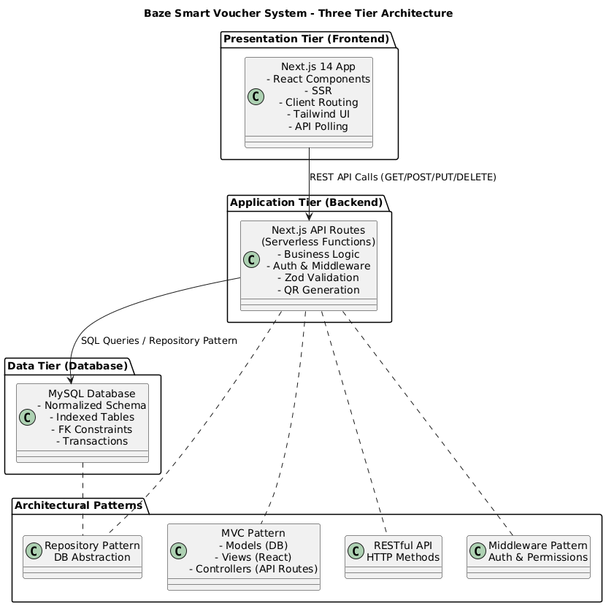

Figure 3.2: Application Architecture

3.8.2 Use Case
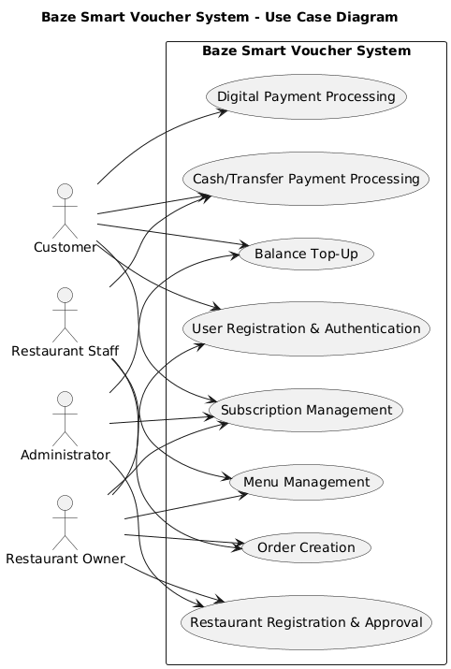

Figure 3.3: Usecase Diagram

3.8.3 Data Design

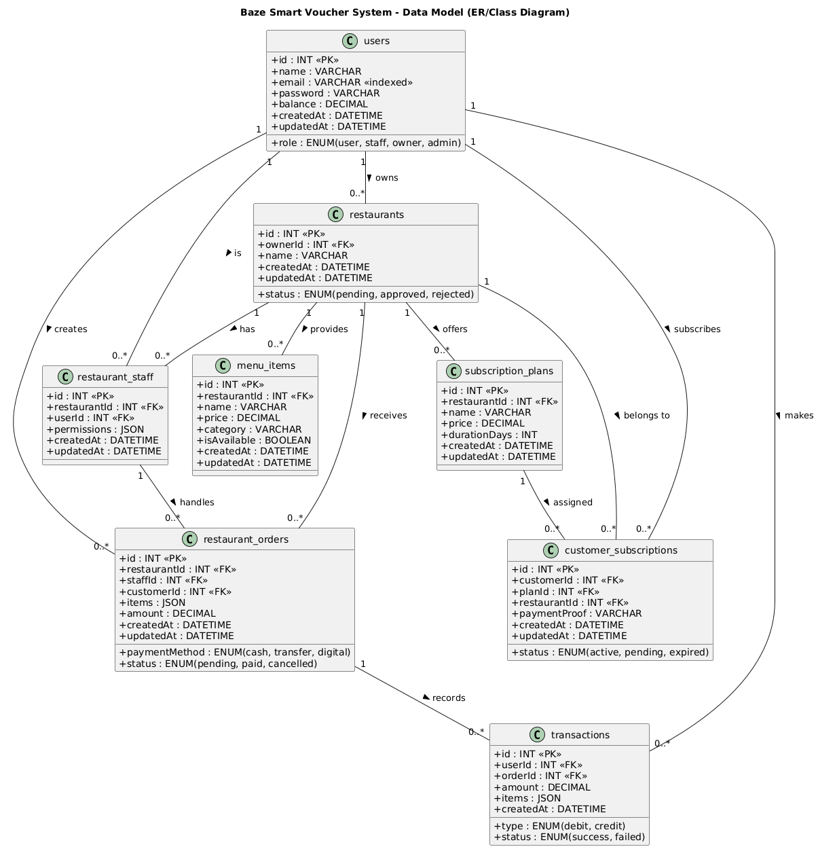

Figure 3.4: Data Design

3.8.4 Activity Diagrams
Activity: Order Payment Flow (Digital)
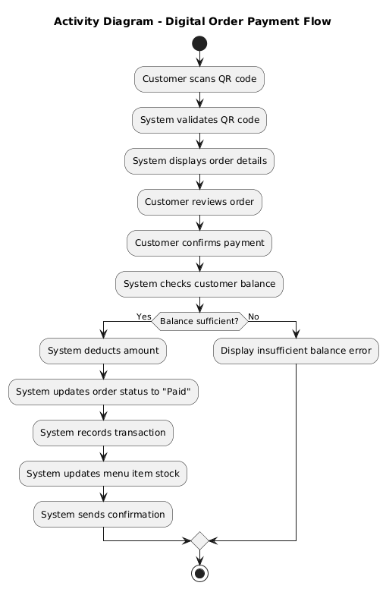

Figure 3.5: Activity Diagram - Order Payment Flow (Digital)

Activity: Restaurant Order Creation
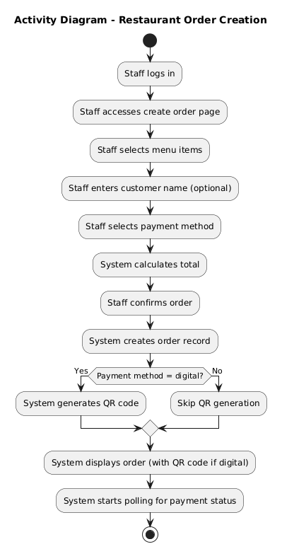

Figure 3.6: Activity Diagram - Restaurant Order Creation

3.8.5 Dataflow Diagram
Level 0 (Context Diagram)
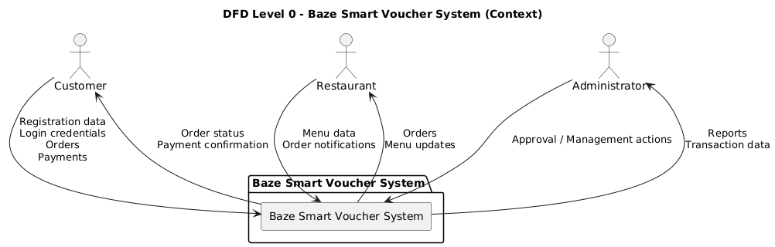

Figure 3.7: Dataflow Diagram - Level 0 (Context Diagram)
Level 1 (System Decomposition)
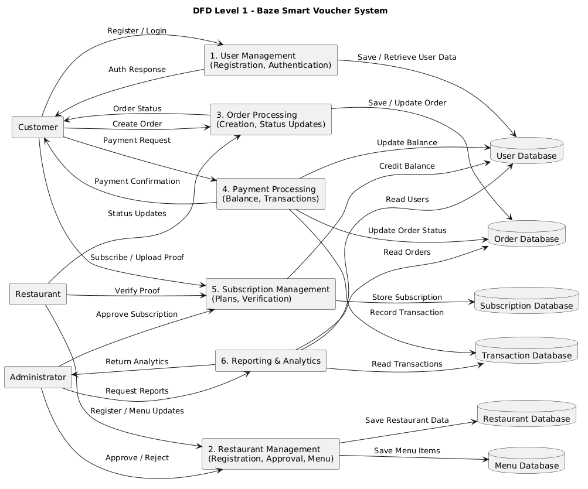

Figure 3.8: Dataflow Diagram - Level 1 (System Decomposition)

3.8.6 Control Flow Diagram
Control Flow: Payment Processing
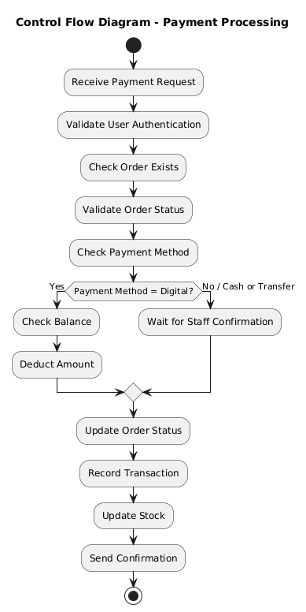

Figure 3.9: Control Flow - Payment Processing

3.8.7 Entity-Relationship Diagram (ERD)

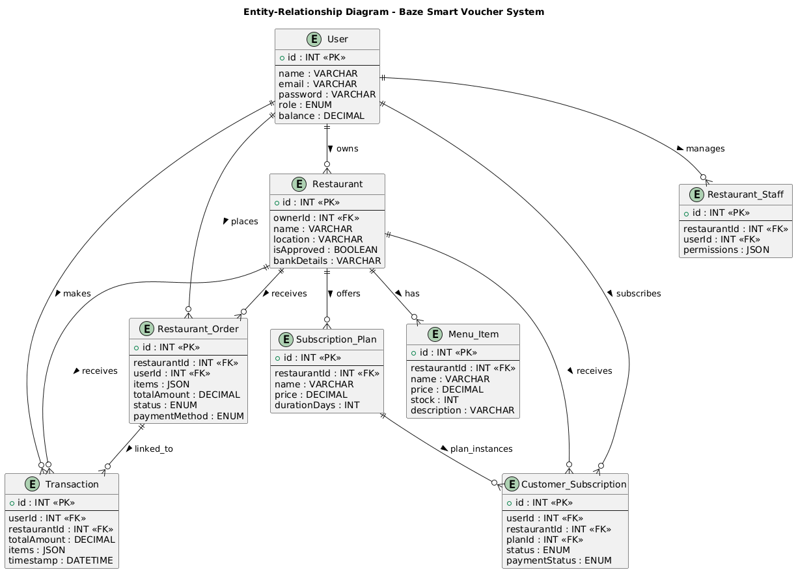

Figure 3.10: Entity Relationship Diagram (ERD)

3.8.8 User Interface Design
This section contains the key User Interface from the web application system. They are as follows:
- Navigation Bar: Consistent header with user info, role-based menu items, logout
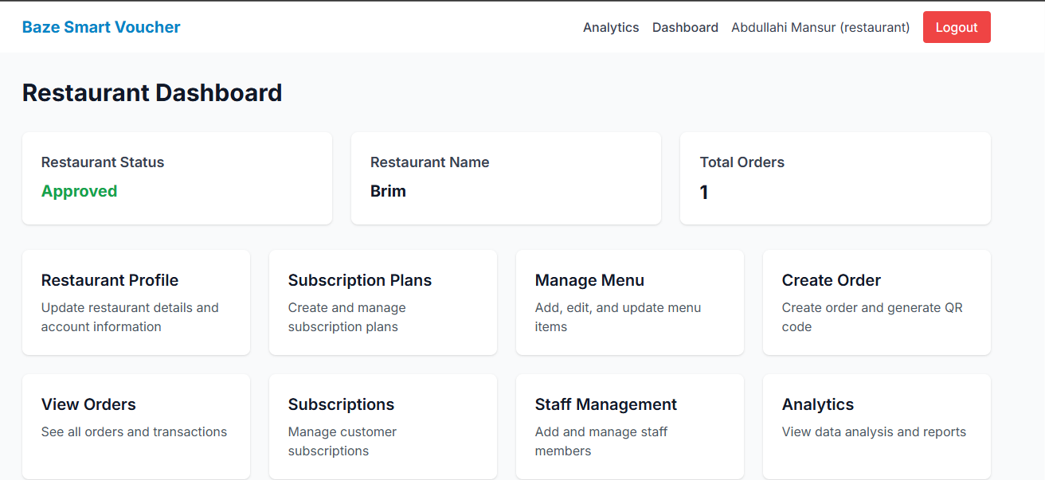

Figure 3.11: Nav Bar and Restaurant Dashboard

- Dashboard Cards: Role-specific information cards (balance, orders, statistics)
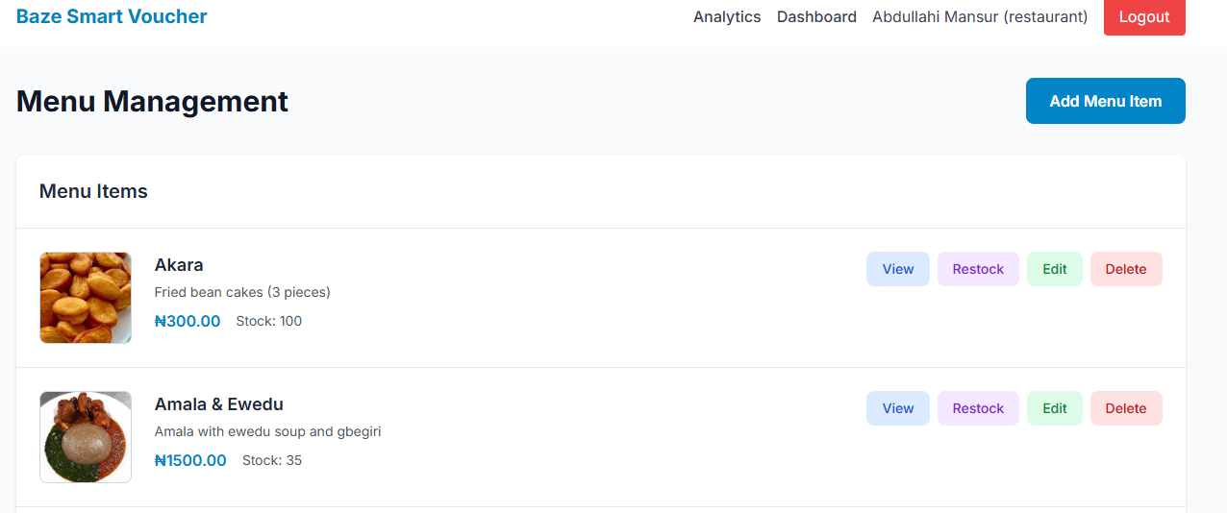

Figure 3.12: Menu Management
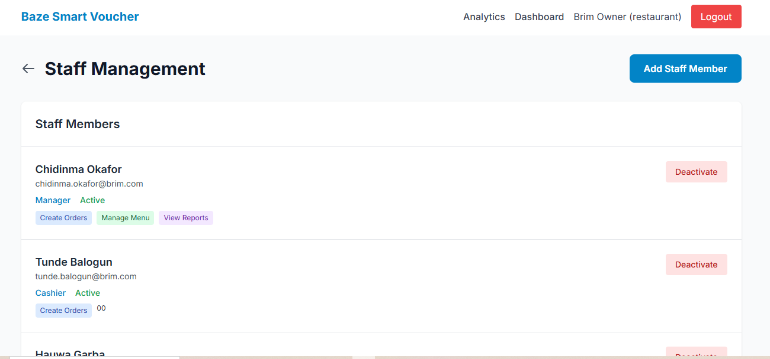

Figure 3.13: Staff Management

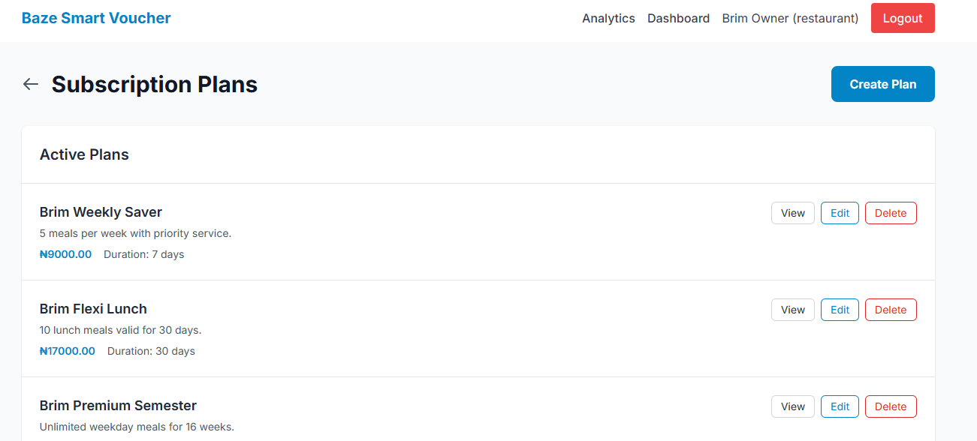

Figure 3.14: Subscription Plans
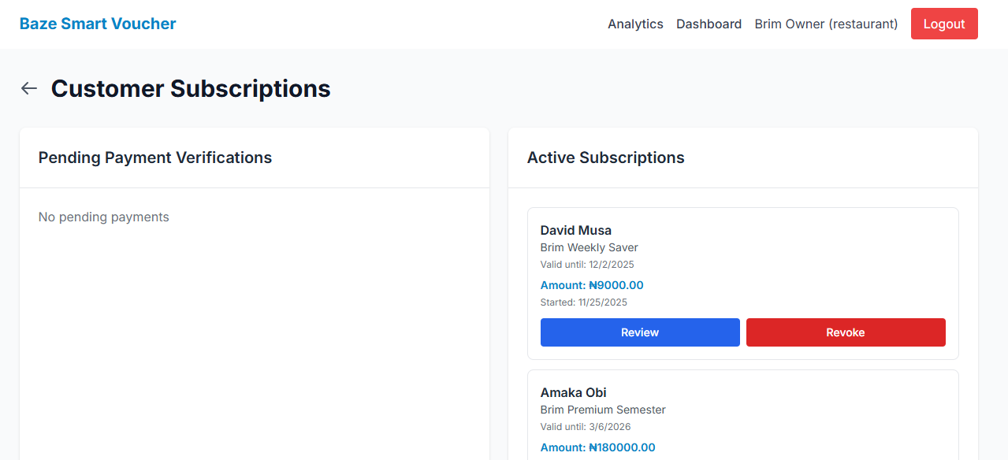

Figure 3.15: Customer Subscription

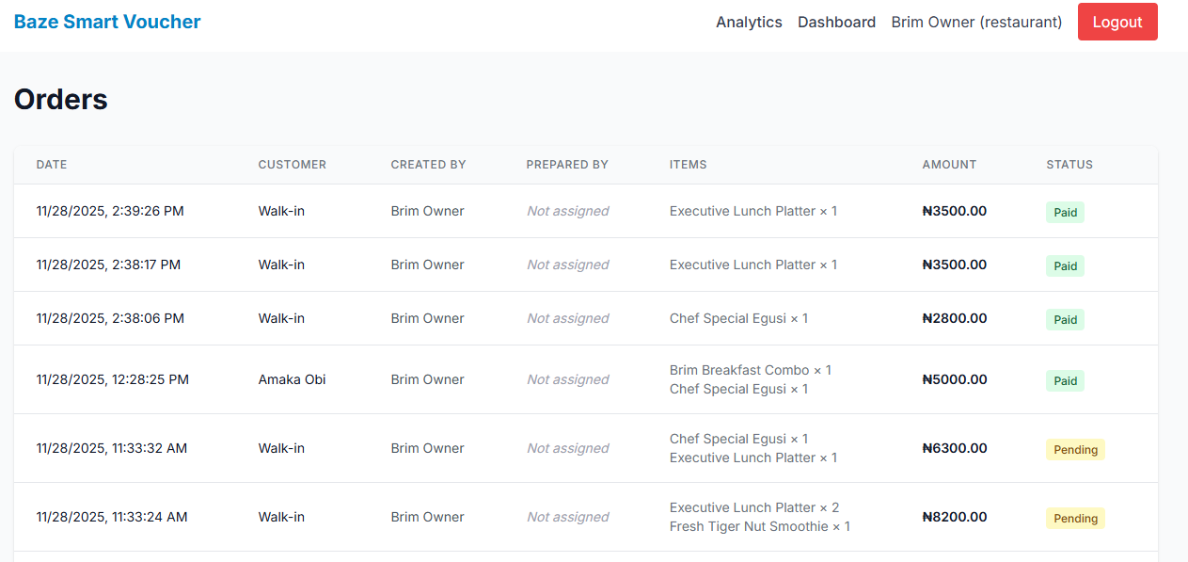

Figure 3.16: Orders
- Forms: Clean input fields with validation feedback, file upload capabilities
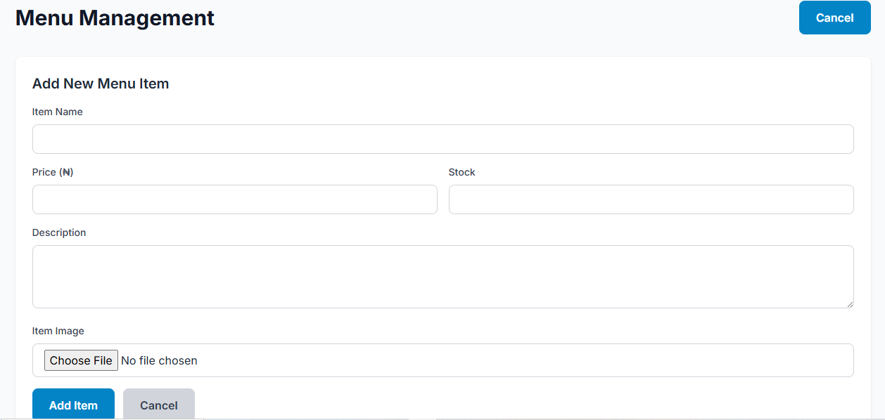

Figure 3.17: Add New Menu Items

- Modals: Overlay dialogs for confirmations, detailed views, forms
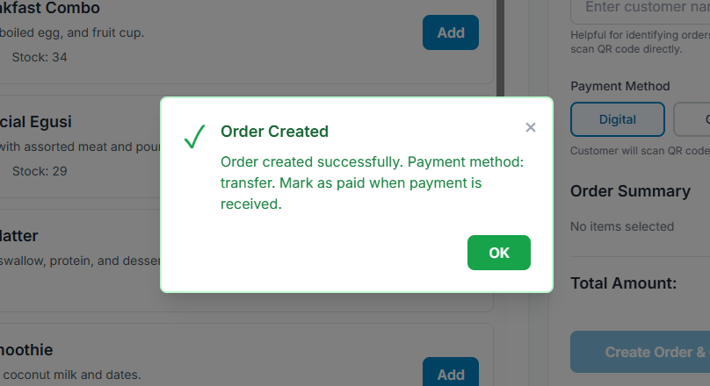

Figure 3.18: Transfer Order Created
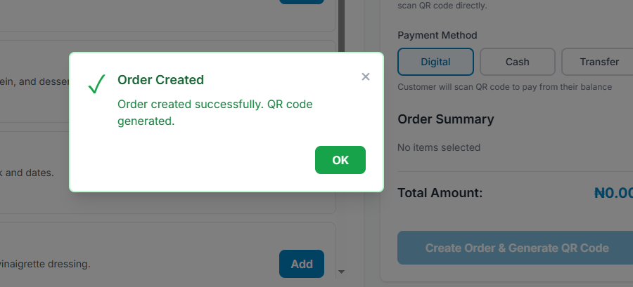

Figure 3.19: Digital (QR Code) Order Created

- QR Code Display: Large, scannable QR codes with download options
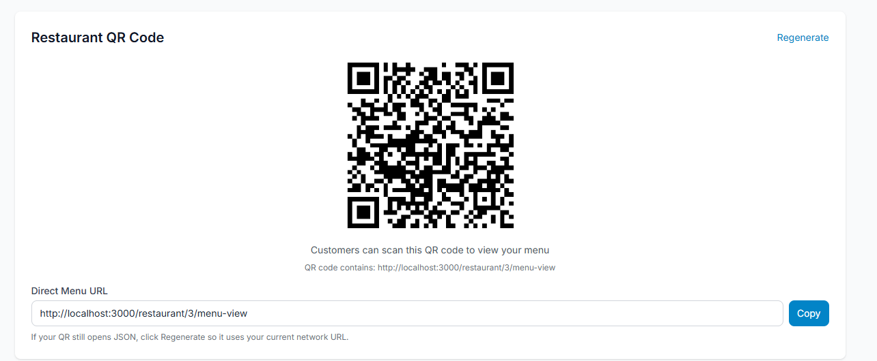

Figure 3.20: Restaurant QR Code
- Status Badges: Color-coded status indicators (Pending, Paid, Completed)
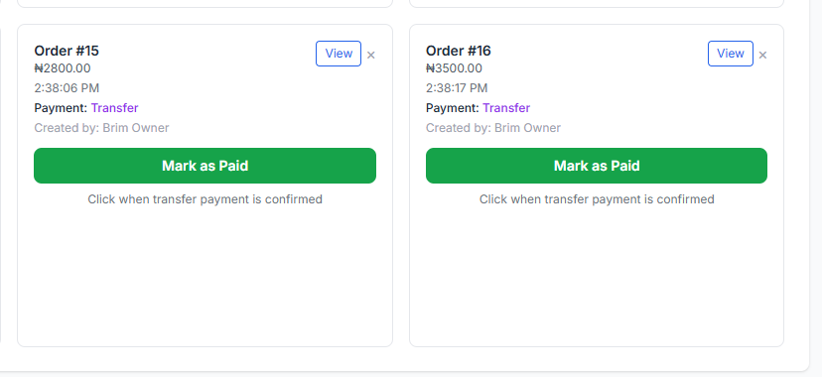

Figure 3.21: Transfer Order Status



Figure 3.22: Order Status
- Action Buttons: Color-coded buttons (View-blue, Edit-green, Delete-red, Restock-purple)
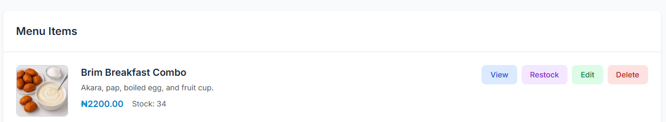

Figure 3.23: Menu Action Buttons

3.9 Summary
This chapter covered the system analysis and design of the Baze Smart Voucher application for a product created under the Agile approach and with proper functional and non-functional requirements. Furthermore, it unveiled a secure, scalable, three-tier architecture, a normalized relational database with eight primary entities, and an easy-to-use, yet flexible user interface. In the end, such a design will foster successful implementation by ensuring continuous adjustment and maintenance ease for the best digital voucher experience at Baze University.

